Supplementary material
Benznidazole therapy saves costs compared to usual follow-up care for indeterminate chronic Chagas disease in a European healthcare setting

Content
Model 2
Starting populations 2
Stratification 2
Parameters of the model 2
Calibration process and results 4
Simulation results 5
QALY weights and disutilities 6
Costs 7
Chronic indeterminate Chagas disease state, treated 7
Chronic Chagas heart disease 8
Chronic Chagas digestive disease 9
Calculation of the incremental net monetary benefit 9
Calculation of expected value of perfect information 10
References 11

Model

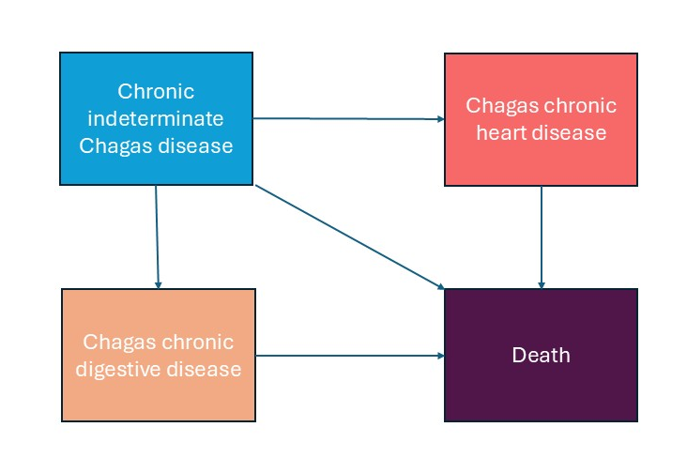
Figure 1. Simplified representation of the Markov model.
The model starts with a Chagas disease patient in the upper left corner (chronic indeterminate Chagas disease). From there, a patient may develop determinate chronic Chagas heart disease (top right corner) or chronic digestive disease (bottom left corner). From all three of these states, a patient may die and transition to the fourth state, death (bottom right corner). The model was stratified by age group and sex.

Starting populations
Starting populations were derived from data on the number and distribution of migrants from Latin America, as provided by the Spanish National Institute of Statistics. Then the estimated burden of Chagas disease provided by Navarro et al. 2022¹ was used to calculate absolute numbers of cases of indeterminate chronic Chagas disease.

Stratification
The data from the Spanish National Institute of Statistics was used to stratify the patients by age group and sex. To keep the population constant over time, the patients that outgrew the model or died were replaced in the next time step with new patients in the first age group.

Parameters of the model
The parameters were selected based on the literature, publicly available data, and by expert consultation. The values obtained from this process where then calibrated to best match Spanish epidemiology (process and results explained below). For the one-way sensitivity analysis (OWSA), a range was determined using values from the literature, which were calibrated. For the probabilistic sensitivity analysis (PSA), the parameters were given probability distributions with hyperparameters also determined by calibration and the literature.
- Probability of transitioning into state with chronic Chagas heart disease per annum
The pre calibration value chosen from the literature was:
1·9% (95% CI 1·3-3·0%) from Chadalawada et al. 2020.²

- After calibration, it was 1·75%, and this was used in the final CEA analysis.
- In the OWSA, the 1-3·0% range was used.
- In the PSA, 1·75% was used as the mean of a Beta distribution, with a 95% CI of 1-3%. The alfa and beta parameters were estimated using the method of moments.

- Mortality due to Chagas heart disease
Relative risk (RR) was used to calculate the mortality risk of patients with Chagas heart disease relative to the baseline population mortality. This relative risk was derived from the literature by dividing the yearly mortality rate reported by Chadalawada et al. 2023³, 6·3% (95% CI 4·9-8), by the yearly population mortality in the 50-55 year group, yielding an RR of 12 (95% CI 4-16).
- After calibration it was RR 2·45.
- In the OWSA, the range used was RR 1·1-5.
- in the PSA, 2·45 was used as a mean and 1·1-5 as the 95% CI of a lognormal distribution.
- Mortality due to Chronic Chagas digestive disease
The RR was used and estimated, taking the values reported by Cucunubá et al. 2016⁴ (RR 2·1, 95% CI 1·52-2·91).
- After calibration, the best value was RR 1·06.
- In the OWSA, the range used was RR 1-2·5.
- In the PSA ,1·06 was used as a mean and 1-2 as the 95% CI of a lognormal distribution.

- Probability of transitioning into state with Chagas digestive disease
The pre-calibration value chosen from the literature was: 1·1% (CI 95% 0·8-1·36), derived from the data reported by Castro et al. 1994.⁵
- After calibration it was 1·4%.
- In the OWSA, the range used was 1-1·5%.
- In the PSA, 1·4% was used as the mean of a Beta distribution and 1-1·5% as the 95% CI. Alfa and beta were estimated using the method of moments.

- Relative risk reduction of progression to Chagas heart disease
The value chosen from the literature was: odds ratio (OR) 0·49 (CI 95% 0·19-1·25), Crespillo-Andújar et al. 2022.⁶ This is not a calibrated parameter.
It was adjusted to include 14·2% treatment discontinuations, as estimated by Crespillo-Andújar et al.⁷ First the value was calculated on the log-scale:
lnOR overall=Pcomp lnOR on+Pdrop ln1=0·.858*ln0·.49
And finally it was converted back to the non-log scale.
OR overall=e0·.858×ln⁡(0·.49))=0·.542

The same method was applied for the confidence interval:
ORlower, ORupper→ORlower0·.858, ORupper0·.858

Final values used for the simulation were:
OR 0·54 (95 % CI 0·25–1·18)
- In the OWSA, the range used was OR 0·25-1·18.
- In the PSA, 0·24 was used as a mean and 0·25-1·18 as the CI of a lognormal distribution.

- Relative risk reduction of progression to digestive Chagas disease

The value chosen from the literature was: RR 0·88 (CI 95%, 0·55-1·42), from Nunes da Costa et al. 2021.⁸ This is not a calibrated parameter. With the adjustment for non-completers, following the same method as above, it was RR 0·90 (95 % CI 0·60–1·37).
- In the OWSA, the range used was RR 0·60-1·3.
- In the PSA, 0·90 was used as the mean and 0·60-1·37 as the 95% CI of a lognormal distribution.

Calibration process and results
To calibrate the model, the parameters were given probability distributions, and the model was run 100 000 times, comparing deaths due to Chagas heart disease to deaths reported by Ramos-Rincón et al.⁹ The sum of the mean squared difference of the point estimates of the model output and the published data reported were used to choose the best simulation and thus the set of parameters that best fit the data. The mean squared difference was 4·63.
The best parameters were:
Probability of developing Chagas heart disease: 0·0175 (fraction of one)
Relative risk of Chagas heart disease mortality: 2·45
Relative risk of Chagas digestive disease mortality: 1·06
Probability of developing digestive Chagas disease: 0·014 (fraction of one)
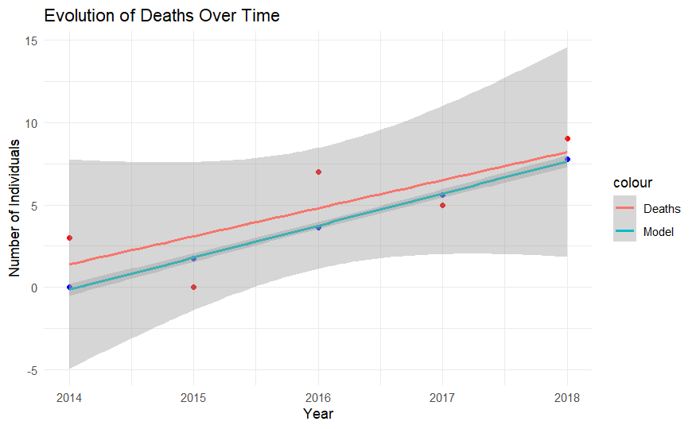

Figure S2. Representation of published data (in red) and modelled data (in blue) (from Ramos-Rincón et al).⁹ Lines represent linear regression lines.

Simulation results
Simulation of the untreated cohort
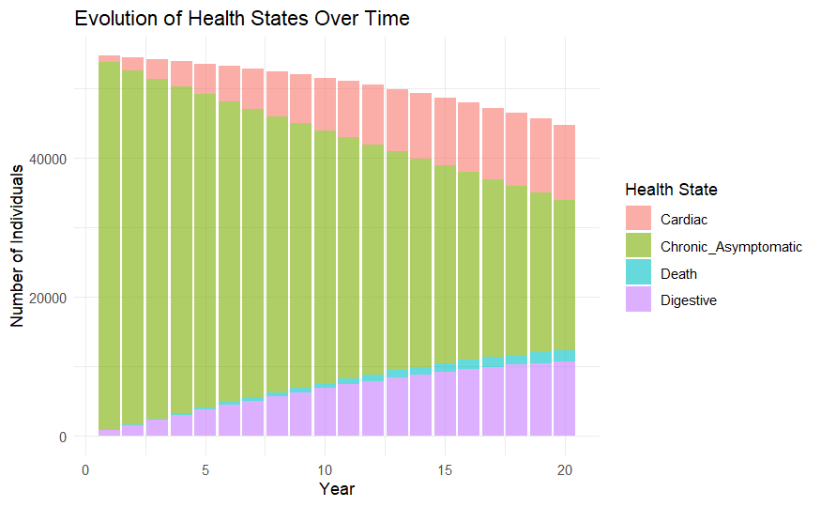
Figure S3. The figure above shows the evolution over time of the number of individuals in the different health states of Chagas disease during the simulation period in the untreated arm.
Simulation of the treated cohort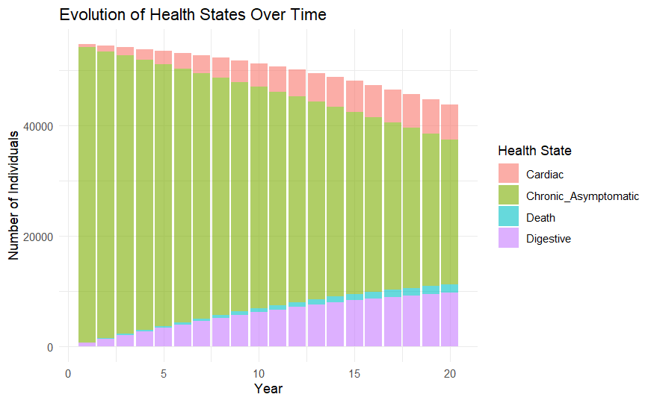
Figure S4. The figure above shows the evolution over time of the number of individuals in the different health states of Chagas disease during the simulation period in the treated arm.

QALY weights and disutilities

The QALY weights used were:
For the chronic indeterminate state: 0·9625, for Chagas heart disease: 0·7171, for Chagas digestive disease: 0·80, and for death: 0, in accordance with Requena-Méndez et al.¹⁰
To adjust for adverse effects, a utility decrement was calculated, considering the incidence, a utility decrement and duration of the adverse effects. The decrement was applied only once.

Adverse event | Incidence | Utility decrement | Duration | QALY loss per patient
Mild–moderate rash or pruritus | 34 %⁷ | 0·1¹¹ | 2 weeks | 0·34 × 0·1 × (2/52) ≈ 0·0013
Gastrointestinal upset | 13 %⁷ | 0·1¹¹ | 1 week | 0·13 × 0·1 × (1/52) ≈ 0·00025
Neurological symptoms (e.g. neuropathy) | 10·5 %⁷ | 0·1¹¹ | 3 weeks | 0·105 × 0·1 × (3/52) ≈ 0·0006
Total expected |  |  |  | ≈ 0·00215 QALYs

The total cohort of patients comprised 55,026 migrants, so a total of 55,026×0·00215=118·308 QALYs were subtracted to account for the adverse events when the cohort of treated patients was simulated.

Costs

We estimated costs for the different states as follows:

Chronic indeterminate Chagas disease state, treated
This state represents patients infected with T. cruzi but who have not yet developed organ involvement. The costs include treatment (only applied in treated simulations) and cost of follow-up and treatment of complications derived from untreated disease. These costs are applied according to the reported frequency of these complications in the different published Spanish cohorts.
Table S1. Costs of treatment and follow-up of patients with chronic indeterminate Chagas disease.
Item | Unit cost (€) | Annual units | Annual cost (€) | Source
Treatment | 131·00 | Once | 0·00 | Direct query to the Department of foreign medicines of the Spanish Agency of Medicines and Medical Devices.
Complete blood count | 10·00 | 2 | 20·00 | BOJA 2024.¹²
Basic biochemistry | 20·00 | 2 | 40·00 | BOJA 2024.¹²
ECG | 40·00 | 1 | 40·00 | BOJA 2024.¹²
Echocardiogram | 100·00 | Baseline and every 5 years | 20·00 | BOJA 2024.¹²
T. cruzi serology | 20·00 | 2 first 2 years and then annually | 20·00 | BOE 2023.¹³
T. cruzi PCR | 44·26 | 2 first 2 years and then annually | 44·26 | BOE 2023.¹³
Cardiac pacemaker | 6,000·00 | 0 | 0·00 | BOJA 2024.¹²
Heart transplant | 100,000·00 | 0 | 0·00 | BOJA 2024.¹²
Implantable cardioverter defibrillator | 25,000·00 | 0 | 0·00 | BOJA 2024.¹²
Ventricular assist device | 60,000·00 | 0 | 0·00 | BOJA 2024.¹²
Barium enema | 80·00 | 0 | 0·00 | BOJA 2024.¹²
Oesophageal barium swallow study | 90·00 | 0 | 0·00 | BOJA 2024.¹²
Gastroscopy | 150·00 | 0 | 0·00 | BOJA 2024.¹²
Medical consultation | 98·00 | 4 during treatment and every six months afterwards | 196·00 | BOJA 2024.¹²
Prednisone 30 mg 30 tablets | 3·76 | 34% of patients | 1·28 | Spanish retail price
Bilastin 20 mg 20 tablets | 5·82 | 34% of patients | 1·98 | Spanish retail price
Metoclopramide 10 mg 10 tablets | 2·00 | 13% of patients | 0·26 | Spanish retail price
Pregabaline 50 mg 50 capsules | 9·8 | 10·5% of patients | 1·03 | Spanish retail price
Total |  |  | 380·26
BOE: Boletín oficial del Estado. BOJA: Boletín oficial de la Junta de Andalucía.

To these annual costs, and in the treatment arm of the simulations, for the first year a sum of €966·07 was added to account for treatment costs, management of adverse effects and the extra follow-up needed during this time. For the second year, a total of €128·52 was added for the same reason.

Chronic Chagas heart disease
This state represents patients infected with T. cruzi who have developed cardiac involvement. The costs include follow-up costs, drug costs, procedures and diverse cardiac devices. These costs are applied according to the reported frequency of these complications in the different published Spanish cohorts.
Table S2. Costs of treatment and follow-up of patients with chronic Chagas heart disease
Item | Unit cost (€) | Annual units | Annual cost (€) | Source
Complete blood count | 10·00 | 2 | 20·00 | BOJA 2024.¹²
Basic biochemistry | 20·00 | 2 | 40·00 | BOJA 2024.¹²
ECG | 40·00 | 2 | 80·00 | BOJA 2024.¹²
Echocardiogram | 100·00 | 1 | 100·00 | BOJA 2024.¹²
T. cruzi serology | 20·00 | 1 | 20·00 | BOE 2023.¹³
T. cruzi PCR | 44·26 | 1 | 44·26 | BOE 2023.¹³
Cardiac pacemaker | 6,000·00 | 0·02 | 120·00 | BOJA 2024.¹²
Heart transplant | 100,000·00 | 0·01 | 1,000·00 | BOJA 2024.¹²
Implantable cardioverter defibrillator | 25,000·00 | 0·03 | 750·00 | BOJA 2024.¹²
Ventricular assist device | 60,000·00 | 0 | 0·00 | BOJA 2024.¹²
Barium enema | 80·00 | 0 | 0 | BOJA 2024.¹²
Barium oesophageal transit study | 90·00 | 0 | 0 | BOJA 2024.¹²
Gastroscopy | 150·00 | 0 | 0 | BOJA 2024.¹²
Medical consultation | 98·00 | 2 | 196·00 | BOJA 2024.¹²
Sacubitril/valsartan | 705·21 | 12 | 8,462·52 | Spanish retail price
Bisoprolol | 5·93 | 12 | 71·16 | Spanish retail price
Dapagliflozin | 46·02 | 12 | 552·24 | Spanish retail price
Furosemide | 2·25 | 12 | 27·00 | Spanish retail price
Hospitalization | 2,727·32 | 0·04 | 109·09 | Spanish retail price
Total |  |  | 11,592·27

BOE: Boletín oficial del Estado. BOJA: Boletín oficial de la Junta de Andalucía.

Chronic Chagas digestive disease
This state represents patients infected with T. cruzi who have developed digestive involvement. The costs include follow-up costs, drug costs, and diverse procedures. These costs are applied according to the reported frequency of these complications in the different published Spanish cohorts.
Table S3. Costs of treatment and follow-up of patients with chronic Chagas digestive disease
Item | Unit cost (€) | Annual units | Annual cost (€) | Source
Complete blood count | 10·00 | 2 | 20·00 | BOJA 2024.¹²
Basic biochemistry | 20·00 | 2 | 40·00 | BOJA 2024.¹²
ECG | 40·00 | 2 | 80·00 | BOJA 2024.¹²
Echocardiogram | 100·00 | 1 | 100·00 | BOJA 2024.¹²
T. cruzi serology | 20·00 | 1 | 20·00 | BOE 2023.¹³
T. cruzi PCR | 44·26 | 1 | 44·26 | BOE 2023.¹³
Cardiac pacemaker | 6,000·00 | 0 | 0·00 | BOJA 2024.¹²
Heart transplant | 100,000·00 | 0 | 0·00 | BOJA 2024.¹²
Implantable cardioverter defibrillator | 25,000·00 | 0 | 0·00 | BOJA 2024.¹²
Ventricular assist device | 60,000·00 | 0 | 0·00 | BOJA 2024.¹²
Barium enema | 80·00 | 0·5 | 80·00 | BOJA 2024.¹²
Barium oesophageal transit study | 90·00 | 0·5 | 90·00 | BOJA 2024.¹²
Gastroscopy | 150·00 | 0·5 | 150·00 | BOJA 2024.¹²
Esophageal manometry | 1,955·00 | 0·05 | 97·75 | BOJA 2024.¹²
Surgery | 6,277·00 | 0·01 | 62·77 | BOJA 2024.¹²
Endoscopic sphincterotomy | 978·00 | 0·01 | 9·78 | BOJA 2024.¹²
Medical consultation | 98·00 | 2 | 196·00 | BOJA 2024.¹²
Total |  |  | 554·56
BOJA: Boletín oficial de la Junta de Andalucía.

Calculation of the incremental net monetary benefit

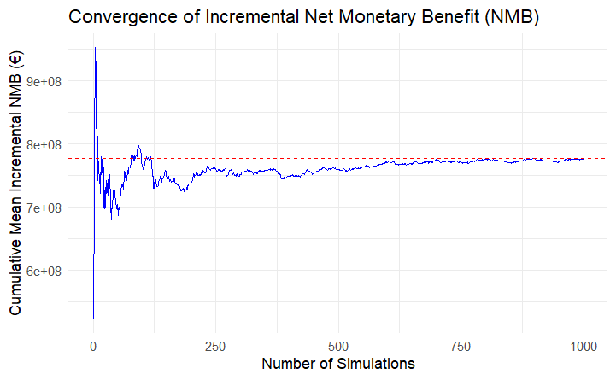

Figure S5. Convergence plot of the cumulative mean incremental net monetary benefit (NMB) over the number of probabilistic sensitivity analysis simulations. The red dashed line indicates the overall mean incremental NMB. The plot suggests that the estimate stabilises after approximately 700–800 simulations, supporting the adequacy of the chosen sample size for decision-making.

Calculation of expected value of perfect information
This calculation is undertaken using the results of the probabilistic sensitivity analysis.
First, we calculate the NMB ((WTP×QALYs)−cost) for each iteration. Then, we calculate the mean of the NMB for each strategy and choose the strategy with the highest expected value. This is the expected value with current information (EVwCI).
In addition, we calculate the expected value with perfect information (EVwPI), which is obtained by using the mean value of the strategy with highest NMB for each iteration.
The difference between the two would be the value of perfect information, and it represents the maximum the healthcare system should be willing to pay for additional information to make a better decision.

References

1 Navarro M, Reguero L, Subirà C, Blázquez-Pérez A, Requena-Méndez A. Estimating chagas disease prevalence and number of underdiagnosed, and undertreated individuals in Spain. Travel Med Infect Dis 2022; 47: 102284.
2 Chadalawada S, Sillau S, Archuleta S, et al. Risk of Chronic Cardiomyopathy Among Patients With the Acute Phase or Indeterminate Form of Chagas Disease: A Systematic Review and Meta-analysis. JAMA Netw Open 2020; 3: e2015072.
3 Chadalawada S, Rassi A, Samara O, et al. Mortality risk in chronic Chagas cardiomyopathy: a systematic review and meta‐analysis. ESC Heart Fail 2021; 8: 5466–81.
4 Cucunubá ZM, Okuwoga O, Basáñez M-G, Nouvellet P. Increased mortality attributed to Chagas disease: a systematic review and meta-analysis. Parasit Vectors 2016; 9: 42.
5 Castro C, Macêdo V, Rezende JM, Prata A. Estudo radiológico longitudinal do esôfago, em área endêmica de doença de Chagas, em um período de 13 anos. Rev Soc Bras Med Trop 1994; 27: 227–33.
6 Crespillo-Andújar C, Comeche B, Hamer DH, et al. Use of benznidazole to treat chronic Chagas disease: An updated systematic review with a meta-analysis. PLoS Negl Trop Dis 2022; 16: e0010386.
7 Crespillo-Andújar C, Venanzi-Rullo E, Lopez-Velez R, et al. Safety Profile of Benznidazole in the Treatment of Chronic Chagas Disease: Experience of a Referral Centre and Systematic Literature Review with Meta-Analysis. Drug Saf 2018; 41: 1035–48.
8 Nunes Da Costa EAP, Victória C, Fortaleza CMCB. Predictors of development of cardiac and digestive disorders among patients with indeterminate chronic Chagas Disease. PLoS Negl Trop Dis 2021; 15: e0009680.
9 Ramos-Rincon J-M, Llenas-García J, Pinargote-Celorio H, et al. Chagas Disease-Related Mortality in Spain, 1997 to 2018. Microorganisms 2021; 9: 1991.
10 Requena-Mendez A, Bussion S, Aldasoro E, et al. Cost-effectiveness of Chagas disease screening in Latin American migrants at primary health-care centres in Europe: a Markov model analysis. Lancet Glob Health 2017; 0: e439–47.
11 Shabaruddin FH, Chen L-C, Elliott RA, Payne K. A Systematic Review of Utility Values for Chemotherapy-Related Adverse Events. PharmacoEconomics 2013; 31: 277–88.
12 Consejería de salud. Orden de 24 de mayo de 2024, por la que se establece el importe de los servicios, actividades y bienes de naturaleza sanitaria, prestados en centros sanitarios del Sistema Sanitario Público de Andalucía, que deben ser retribuidos mediante precios públicos por los terceros obligados legalmente al pago. 2024.
13 Ministerio de Ciencia e innovación. Resolución de 14 de noviembre de 2023, del Instituto de Salud Carlos III, O.A., M.P., por la que se modifica el Anexo de la Resolución de 3 de abril de 2019, por la que se establecen los precios públicos correspondientes a la prestación de servicios y actividades del organismo. Bol Of Estado 2023; published online Dec 5.

